Formularios:TextField
import { Box, Button, TextField } from "@mui/material";
import { useState } from "react";

export default function Register() {
const [email, setEmail] = useState("");
const [error, setError] = useState({
error: false,
message: "",
});

const emailValidation = (email) => {
// expresion regular para validar email
const regex = /^[A-Z0-9._%+-]+@[A-Z0-9.-]+\.[A-Z]{2,}$/i;
return regex.test(email);
};

const onSubmit = (e) => {
e.preventDefault();
if (!emailValidation(email)) {
setError({
error: true,
message: "El email no es valido",
});
return;
}
console.log(email);
setError({
error: false,
message: "",
});
};

return (
<>
<h1>Register</h1>
<Box
component="form"
onSubmit={onSubmit}
autoComplete="off"
>
<TextField
label="Email"
variant="outlined"
id="email"
type="email"
fullWidth
required
error={error.error}
helperText={error.message}
onChange={(e) => setEmail(e.target.value)}
value={email}
/>
<Button
variant="outlined"
type="submit"
sx={{ mt: 2 }}
>
Submit
</Button>
</Box>
</>
);
}

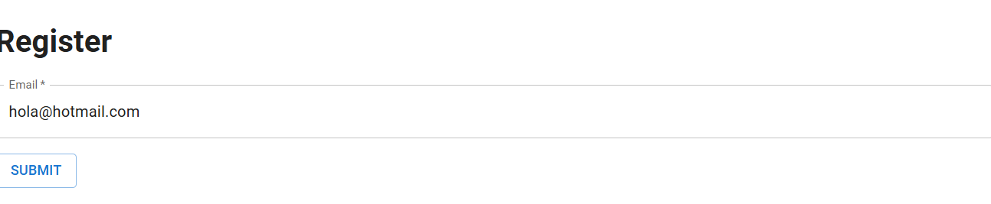

Formulario mas campos:
import React, { useState } from 'react';
import './App.css';
import { Box, TextField, Grid, Card, CardContent, FormControl, Typography, Select, MenuItem, InputLabel } from '@mui/material';
import { LoadingButton } from '@mui/lab'

const dataEspecialist = [
{
id: 1,
descriptions: 'Frontend',
},
{
id: 2,
descriptions: 'Backend',
},
{
id: 3,
descriptions: 'Frontend && Backend',
}
]

function App() {
const [loading, setLoading] = useState(false);
const [formData, setFormData] = useState({
firstname: '',
lastname: '',
rol: 0

});

const { firstname, lastname, rol } = formData;

const handleOnchange = (e) => {
console.log([e.target.name], e.target.value)
setFormData({ ...formData, [e.target.name]: e.target.value });
}

const handleSubmit = (firstname, lastname, rol) => {
console.log(firstname, lastname, rol);
setLoading(true)
alert(`datos formularios:::, ${firstname}, ${lastname}, ${rol}`)
setTimeout(() => {
setLoading(false)
}, 3000);
}

return (
<div className="App">
<header className="App-header">
<Typography component="h2" variant="h2" >Registro de Usuario</Typography>
<Box my={2}>
<Card>
<CardContent>
<Grid container direction="row" spacing={2}>
<Grid item xs={12} sm={12} md={12} lg={12} xl={12}>

<TextField
error={false}
label="First Name"
type="text"
name="firstname"
value={firstname}
onChange={handleOnchange}
margin="dense"
fullWidth
variant="outlined"
helperText="Campo obligatorio"
/>

</Grid>
<Grid item xs={12} sm={12} md={12} lg={12} xl={12}>

<TextField
error={false}
label="Last Name"
type="text"
name="lastname"
value={lastname}
onChange={handleOnchange}
margin="dense"
fullWidth
variant="outlined"
helperText="Campo obligatorio"
/>

</Grid>
<Grid item xs={12} sm={12} md={12} lg={12} xl={12}>
<FormControl sx={{ width: '100%' }}>
<InputLabel id="demo-simple-select-label">Rol Develop</InputLabel>
<Select
name="rol"
value={rol}
fullWidth
label="Rol Develop"
onChange={handleOnchange}>
<MenuItem value={0}>Seleccione</MenuItem>
{dataEspecialist && dataEspecialist.map((d, index) => (
<MenuItem key={d.id} value={d.id}>{d.descriptions}</MenuItem>
))}
</Select>
</FormControl>
</Grid>
<Grid item xs={12} sm={12} md={12} lg={12} xl={12}>
<Box sx={{ '& > button': { m: 1 } }}>
<LoadingButton
size="small"
onClick={() => handleSubmit(firstname, lastname, rol)}
loading={loading}
variant="outlined"
disabled={!loading ? false : true}
>
Enviar
</LoadingButton>
</Box>
</Grid>
</Grid>
</CardContent>
</Card>

</Box>

</header>
</div>
);
}

export default App;

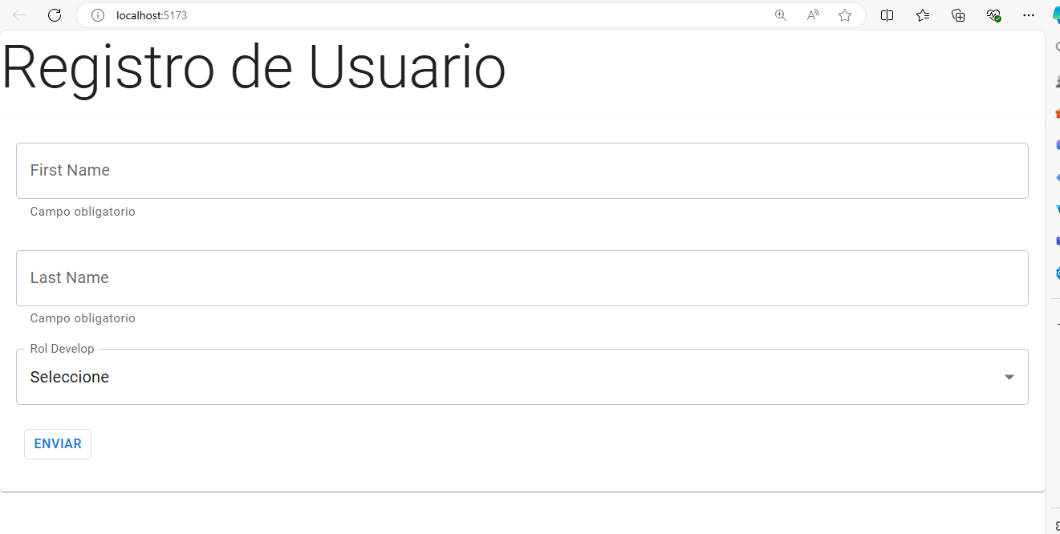
Menus:
- Colocar el comando de react router: npm install react-router-dom@6 y colocar el siguiente comando en main.jsx
ReactDOM.createRoot(document.getElementById('root')).render(
<BrowserRouter>
<App/>
</BrowserRouter>,
)

- Crear componentes: Register, Home y Login

Register.jsx

export default function Register() {
return (
<div>
<h1>Register</h1>
</div>
);
}

Home.jsx
export default function Home() {
return (
<div>
<h1>Home</h1>
</div>
);
}

Login.jsx
export default function Login() {
return (
<div>
<h1>Login</h1>
</div>
);
}

- Copiar el siguiente código en App.jsx
- import { Container } from "@mui/material";
- import { Route, Routes } from "react-router-dom";

- import Navbar from "./NavBar";
- import Home from "./Home";
- import Login from "./Login";
- import Register from "./Register";

- import MenuIcon from "@mui/icons-material/Menu";
- import InboxIcon from "@mui/icons-material/Inbox";
- import DraftsIcon from "@mui/icons-material/Drafts";

- const navegationLinks = [
- {
- title: "Home",
- path: "/",
- icon: <InboxIcon />,
- },
- {
- title: "Login",
- path: "/login",
- icon: <DraftsIcon />,
- },
- {
- title: "Register",
- path: "/register",
- icon: <MenuIcon />,
- },
- ];

- export default function App() {
- return (
- <>
- <Navbar navegationLinks={navegationLinks} />
- <Container sx={{ mt: 5 }}>
- <Routes>
- <Route
- path="/"
- element={<Home />}
- />
- <Route
- path="/login"
- element={<Login />}
- />
- <Route
- path="/register"
- element={<Register />}
- />
- </Routes>
- </Container>
- </>
- );
- }

4. Copiar el siguiente código en NavBar.jsx
import { AppBar, Button, Drawer,IconButton,Toolbar,Typography} from "@mui/material";
import NavListDrawer from "./NavListDrawer";
import { useState } from "react";

import MenuIcon from "@mui/icons-material/Menu";
import { Box } from "@mui/system";

import { NavLink } from "react-router-dom";

export default function Navbar({ navegationLinks }) {
const [open, setOpen] = useState(false);

return (
<>
<AppBar position="static">
<Toolbar>
<IconButton
color="inherit"
size="large"
onClick={() => setOpen(true)}

edge="start"
>
<MenuIcon />
</IconButton>
<Typography
variant="h6"
sx={{ flexGrow: 1 }}
>
News
</Typography>

<Box sx={{ display: { xs: "none", sm: "block" } }}>
{navegationLinks.map((item) => (
<Button
color="inherit"
key={item.title}
component={NavLink}
to={item.path}
>
{item.title}
</Button>
))}
</Box>
</Toolbar>
</AppBar>

<Drawer
open={open}
anchor="left"
onClose={() => setOpen(false)}

>
<NavListDrawer
navegationLinks={navegationLinks}
component={NavLink}
setOpen={setOpen}
/>
</Drawer>
</>
);
}

5. Copiar el siguiente código en NavListDrawer.jsx

import {List, ListItem, ListItemButton,ListItemIcon,ListItemText} from "@mui/material";
import { Box } from "@mui/system";

export default function NavListDrawer({ navegationLinks, component, setOpen }) {
return (
<Box sx={{ width: 250 }}>
<nav>
<List>
{navegationLinks.map((item) => (
<ListItem
disablePadding
key={item.title}
>
<ListItemButton
component={component}
to={item.path}
onClick={() => setOpen(false)}
>
<ListItemIcon>{item.icon}</ListItemIcon>
<ListItemText>{item.title}</ListItemText>
</ListItemButton>
</ListItem>
))}
</List>
</nav>
</Box>
);
}

